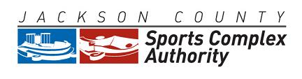

May 19, 2015
2:00 P.M.
Arrowhead Stadium
Kansas City, Missouri 64129

AGENDA

- Roll Call
- Approval Of Regular Meeting Minutes Of April 21, 2015
- Approval Of Payment Of Invoices For April 2015
- Approval Of Financial Statement For April 2015
- Resolution No. 14-04: Common Area Agreement with Teams – HOLD
- General Counsel’s Report
- Executive Director’s Report
- Other Business
- Adjournment
________________________________________________________________________
The meeting is open to the public. Any member of the public may observe and attend the public meeting at the office identified above. The Authority may hold a closed session to discuss confidential or privileged communications with its legal counsel, real estate transactions, legal matters and personnel pursuant to Section 610.021(1), (2), and (3) RSMo. Some members of the Authority may attend by telephone.
Any person with a disability desiring reasonable accommodation to attend this meeting should contact Jim Rowland at 816-920-4604 at least 12 hours prior to the meeting.
___

