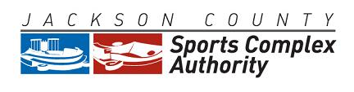

July 18, 2023
2:00 P.M.
Arrowhead Stadium
Kansas City, Missouri 64129

AGENDA

- Roll Call
- Approval of Regular Meeting Minutes of June 20, 2023
- Approval of Payment of Invoices for June 2023
- Approval of Financial Statements for June 2023
- 2022 Financial Audit
- Resolution No. 23-06: Chiefs RMMO Disbursement Request
- Election of Officers
- General Counsel’s Report
- Executive Director’s Report
- Other Business
- Adjournment
________________________________________________________________________
The meeting is open to the public. Any member of the public may observe and attend the public meeting at the office identified above. The Authority may hold a closed session to discuss (1) legal actions, causes of action or litigation involving the Authority, (2) confidential or privileged communications between the Authority or its representatives and its attorneys, (3) leasing, purchase or sale of real estate where public knowledge of the transaction might adversely affect the legal consideration thereof, (4) hiring, firing, disciplining or promoting of particular employees by a public governmental body when personal information about the employee is discussed or recorded pursuant to Section 610.021(1), (2), and (3) RSMo. Some members of the Authority may attend by telephone.
Any person with a disability desiring reasonable accommodation to attend this meeting should contact Anna Mincher at 816-920-4601 at least 12 hours prior to the meeting.
____

