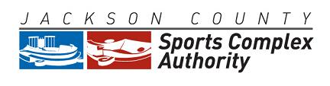

June 21, 2016
2:00 P.M.
Arrowhead Stadium
Kansas City, Missouri 64129

AGENDA

- Roll Call
- Approval Of Regular Meeting Minutes Of May 17, 2016
- Approval Of Payment Of Invoices For May 2016
- Approval Of Financial Statements For May 2016
- Resolution No. 16-08: Hanrahan Paving Asphalt Repair Contract
- Resolution No. 16-09: Guier Fence Contract
- General Counsel’s Report
- Executive Director’s Report
- Other Business
- Adjournment
________________________________________________________________________
The meeting is open to the public. Any member of the public may observe and attend the public meeting at the office identified above. The Authority may hold a closed session to discuss confidential or privileged communications with its legal counsel, real estate transactions, legal matters and personnel pursuant to Section 610.021(1), (2), and (3) RSMo. Some members of the Authority may attend by telephone.
Any person with a disability desiring reasonable accommodation to attend this meeting should contact Anna Mincher at 816-920-4601 at least 12 hours prior to the meeting.
___

